Example 1
Assume that a set R_{q} containing the relevant documents for q has been defined. Without loss of generality, assume further that the set R_{q} is composed of the following documents

R_{q} = {d₃, d₅, d₉, d₂₅, d₃₉, d₄₄, d₅₆, d₇₁, d₈₉, d₁₂₃}

i | Document Id | Relevant | Recall | Precision
1 | d₁₂₃ | ✓ | 0.1 | 100%
2 | d₈₄ |  | 0.1 | 50%
3 | d₅₆ | ✓ | 0.2 | 67%
4 | d₆ |  | 0.2 | 50%
5 | d₈ |  | 0.2 | 40%
6 | d₉ |  | 0.3 | 50%
7 | d₅₁₁ |  | 0.3 | 43%
8 | d₁₂₉ |  | 0.3 | 38%
9 | d₁₈₇ |  | 0.3 | 33%
10 | d₂₅ |  | 0.4 | 40%
11 | d₃₈ |  | 0.4 | 36%
12 | d₄₈ |  | 0.4 | 33%
13 | d₂₅₀ |  | 0.4 | 31%
14 | d₁₁₃ |  | 0.4 | 29%
15 | d₃ |  | 0.5 | 33%

 |  | 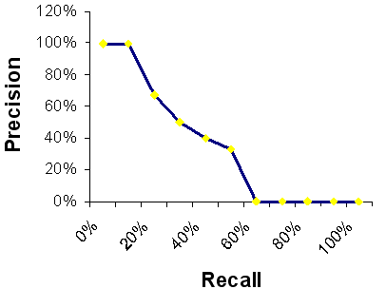
  Level | Interpolated Precision
  0% | 100%
  10% | 100%
  20% | 67%
  30% | 50%
  40% | 40%
  50% | 33%
  60% | 0%
  70% | 0%
  80% | 0%
  90% | 0%
  100% | 0%

Example 2
Assume that a set R_{q} containing the relevant documents for q has been defined. Without loss of generality, assume further that the set R_{q} is composed of the following documents
R_{q} = {d₃, d₅₆, d₁₂₉}

i | Document Id | Relevant | Recall | Precision
1 | d₁₂₃ |  | 0.000 | 0%
2 | d₈₄ |  | 0.000 | 0%
3 | d₅₆ | ✓ | 0.333 | 33%
4 | d₆ |  | 0.333 | 25%
5 | d₈ |  | 0.333 | 20%
6 | d₉ |  | 0.333 | 17%
7 | d₅₁₁ |  | 0.333 | 14%
8 | d₁₂₉ |  | 0.666 | 25%
9 | d₁₈₇ |  | 0.666 | 22%
10 | d₂₅ |  | 0.666 | 20%
11 | d₃₈ |  | 0.666 | 18%
12 | d₄₈ |  | 0.666 | 17%
13 | d₂₅₀ |  | 0.666 | 15%
14 | d₁₁₃ |  | 0.666 | 14%
15 | d₃ |  | 1.000 | 20%

- So, at recall levels 0%, 10%, 20%, and 30% the interpolated precision is 33.3%
- At recall levels 40%, 50%, and 60% interpolated precision is 25%
- And at recall levels 70%, 80%, 90% and 100%, interpolated precision is 20%

 |  | 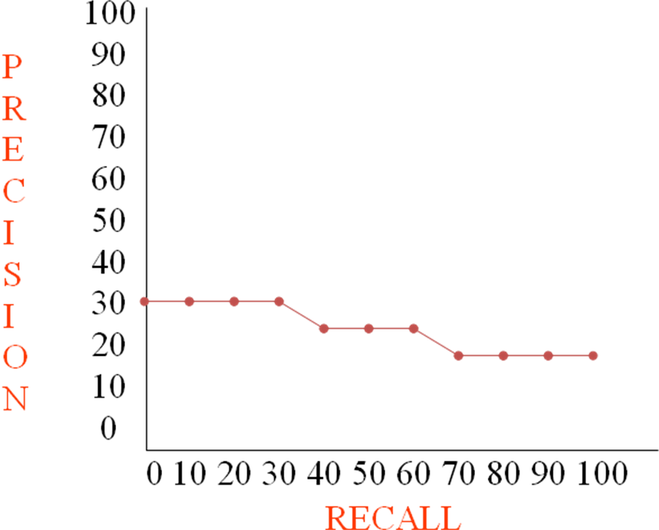
  Level | Interpolated Precision
  0% | 33%
  10% | 33%
  20% | 33%
  30% | 33%
  40% | 25%
  50% | 25%
  60% | 25%
  70% | 20%
  80% | 20%
  90% | 20%
  100% | 20%

